NETLAB Lab 4: Understanding Network and Port Address Translation
Required Screenshots:
Step 11 Page 12 of 33

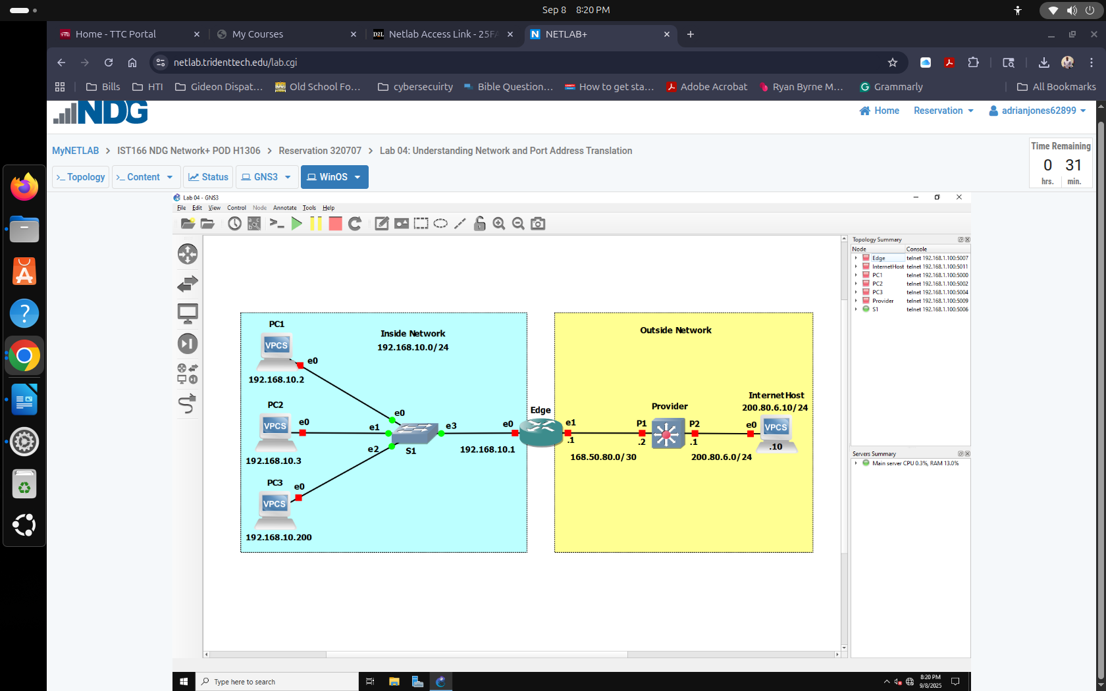

Step 15d Page 15 of 33

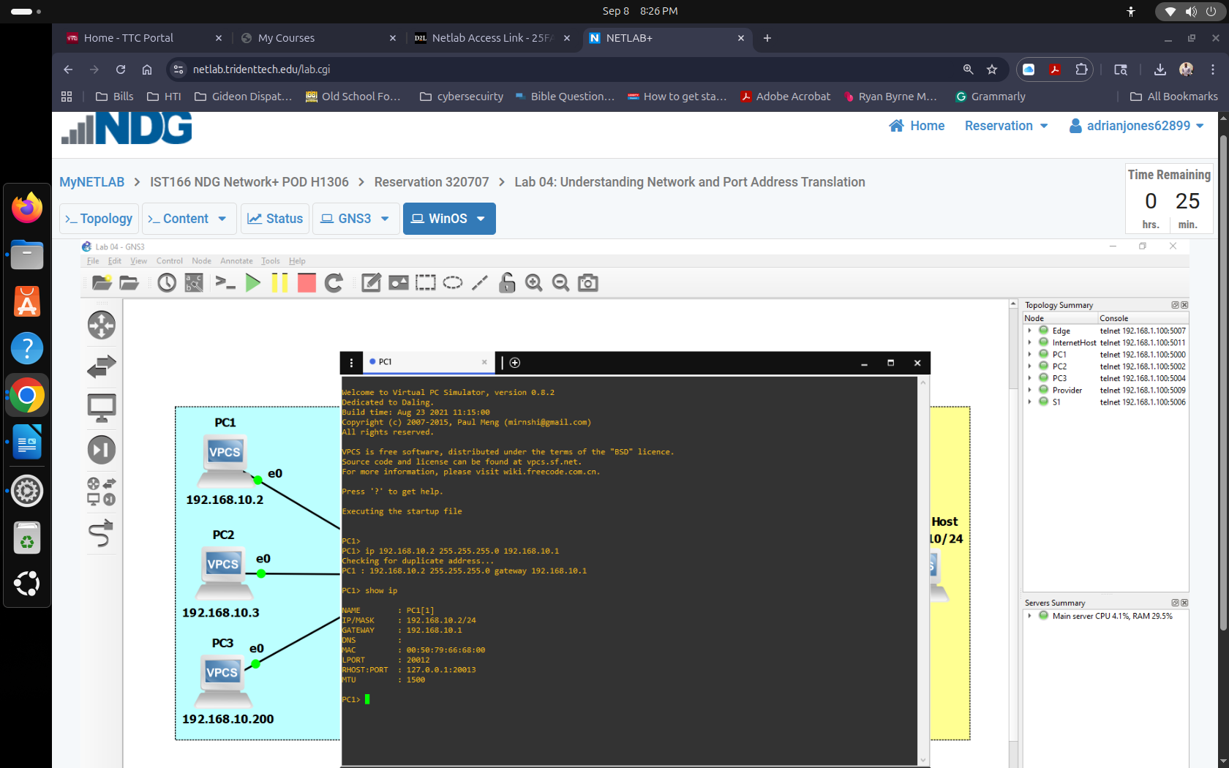

Step 15e Page 16 of 33 (Show results for both PCs)
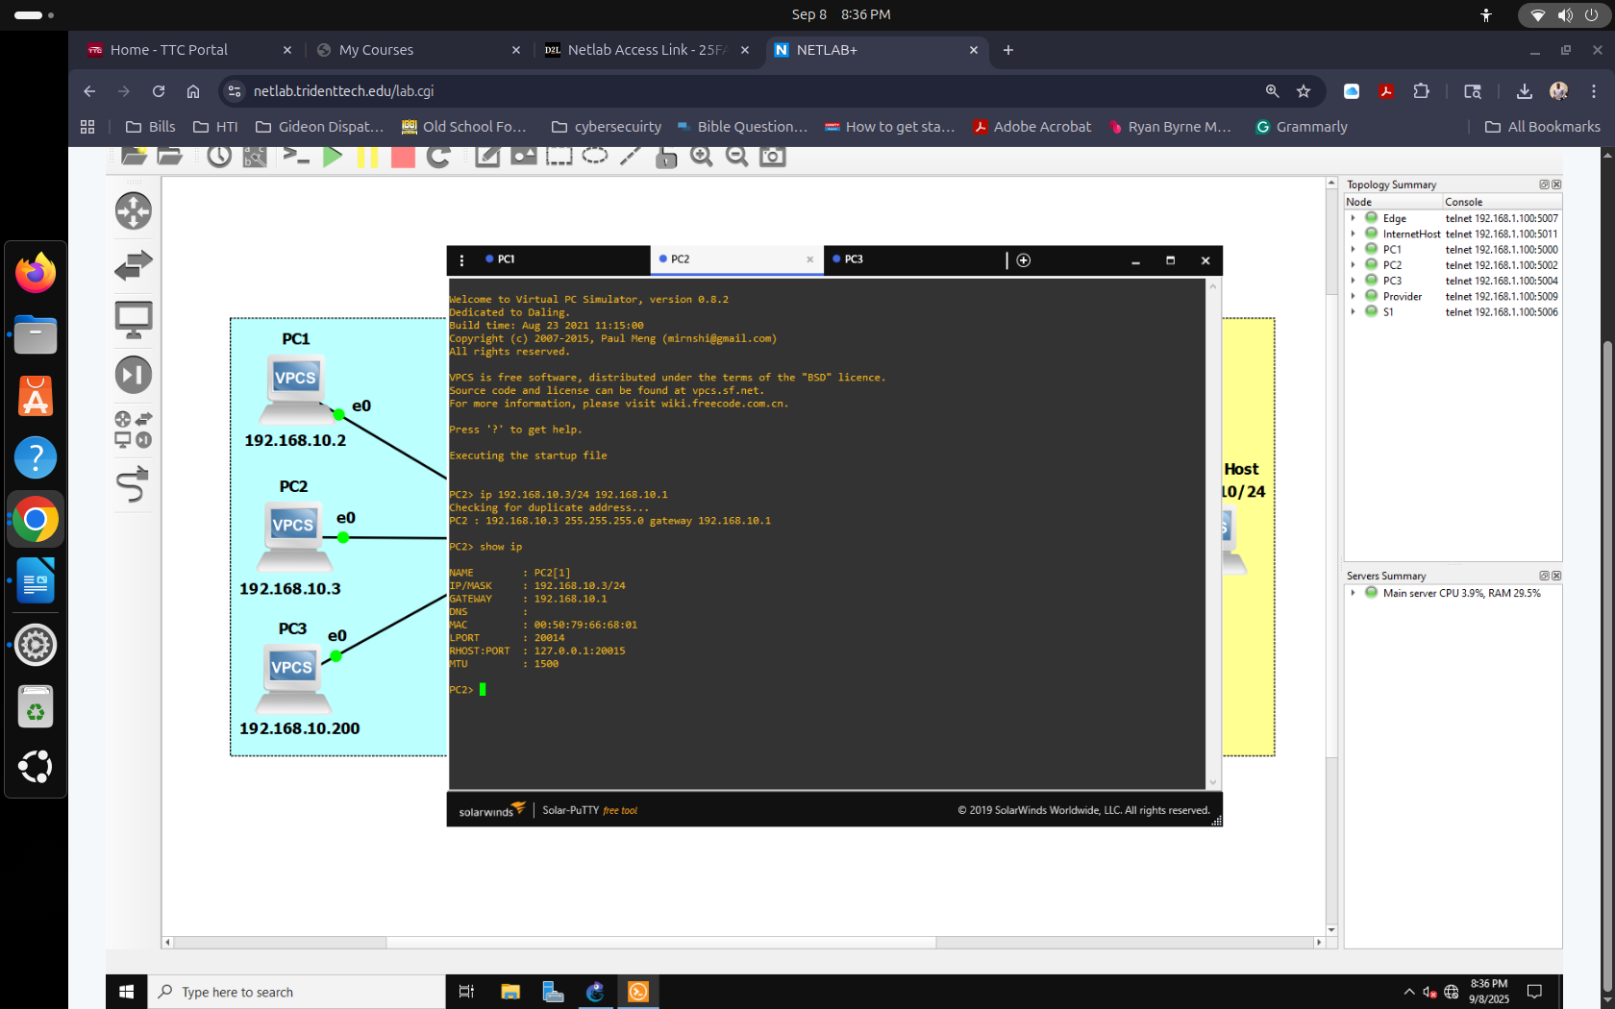

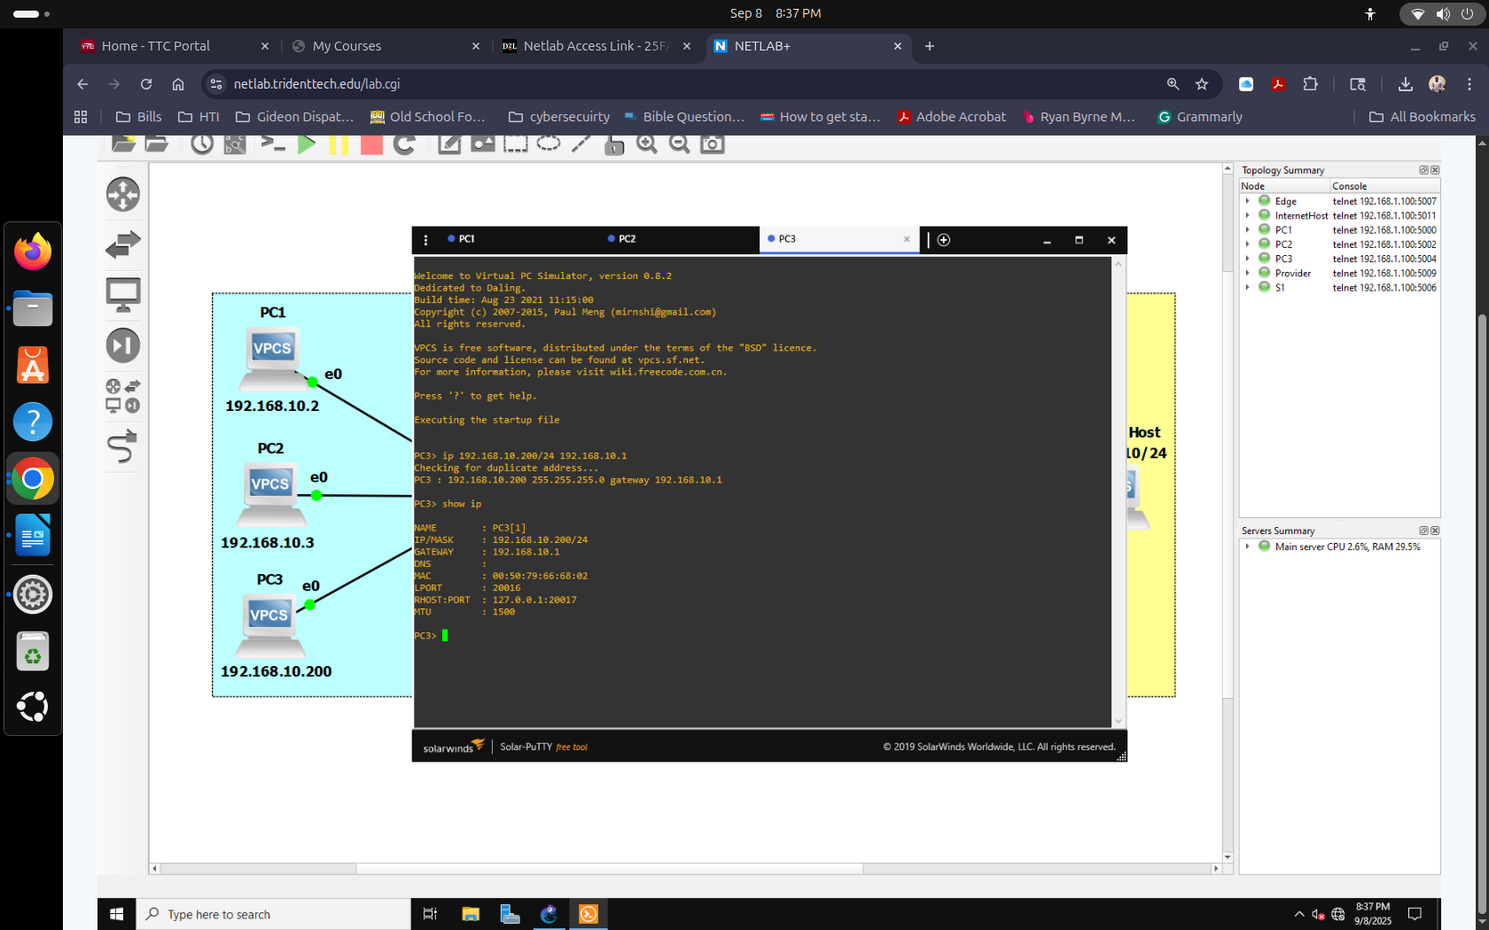

Step 16k Page 19 of 33
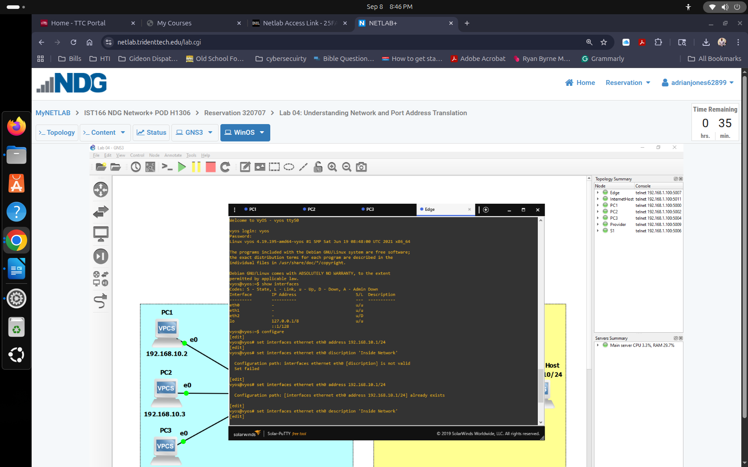
Step 7 Page 21 of 33
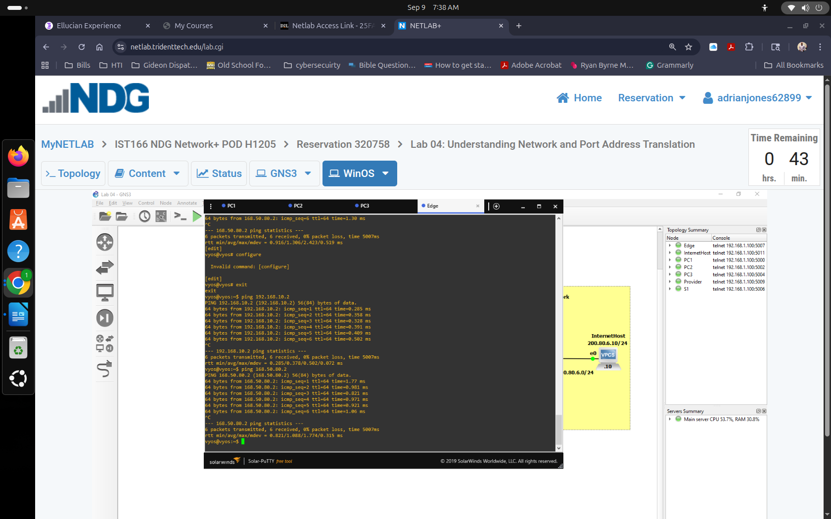
Step 3 Page 23 of 33
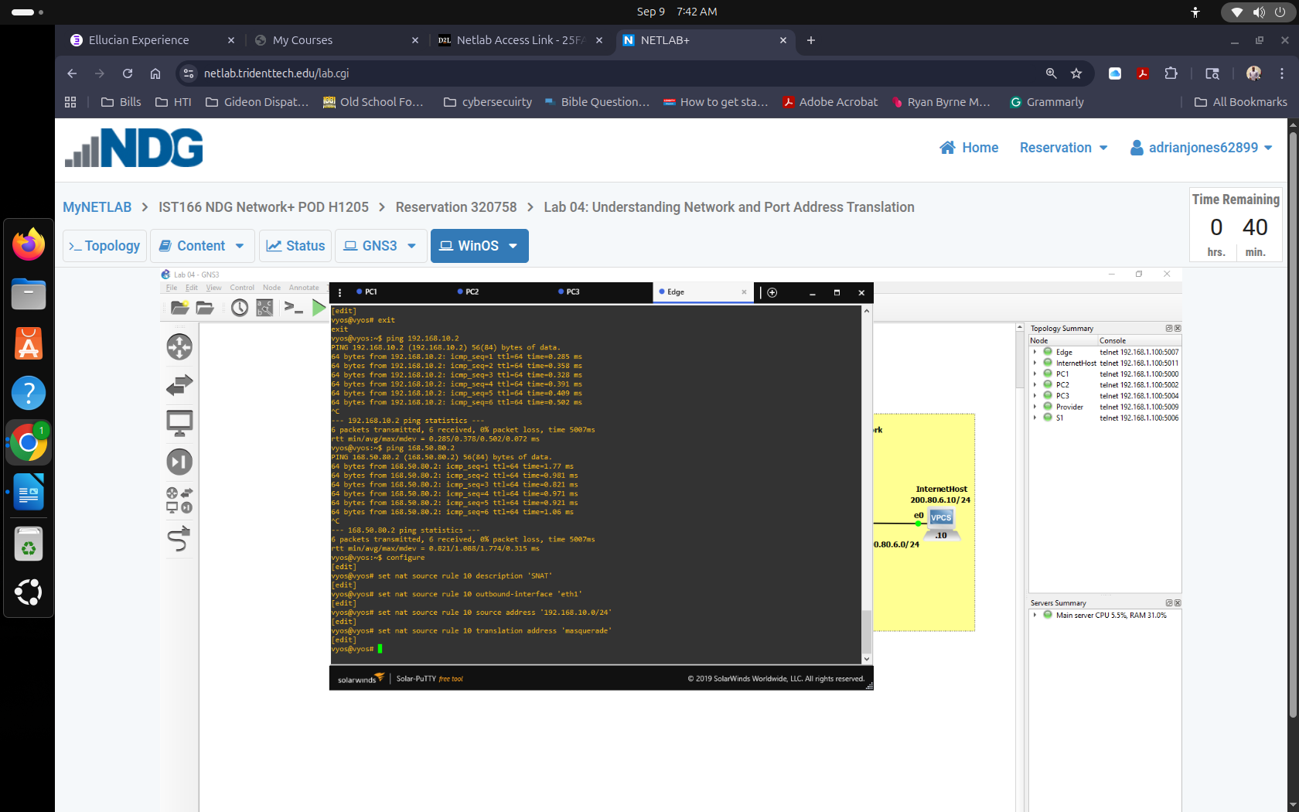
Step 12 Page 26 of 33
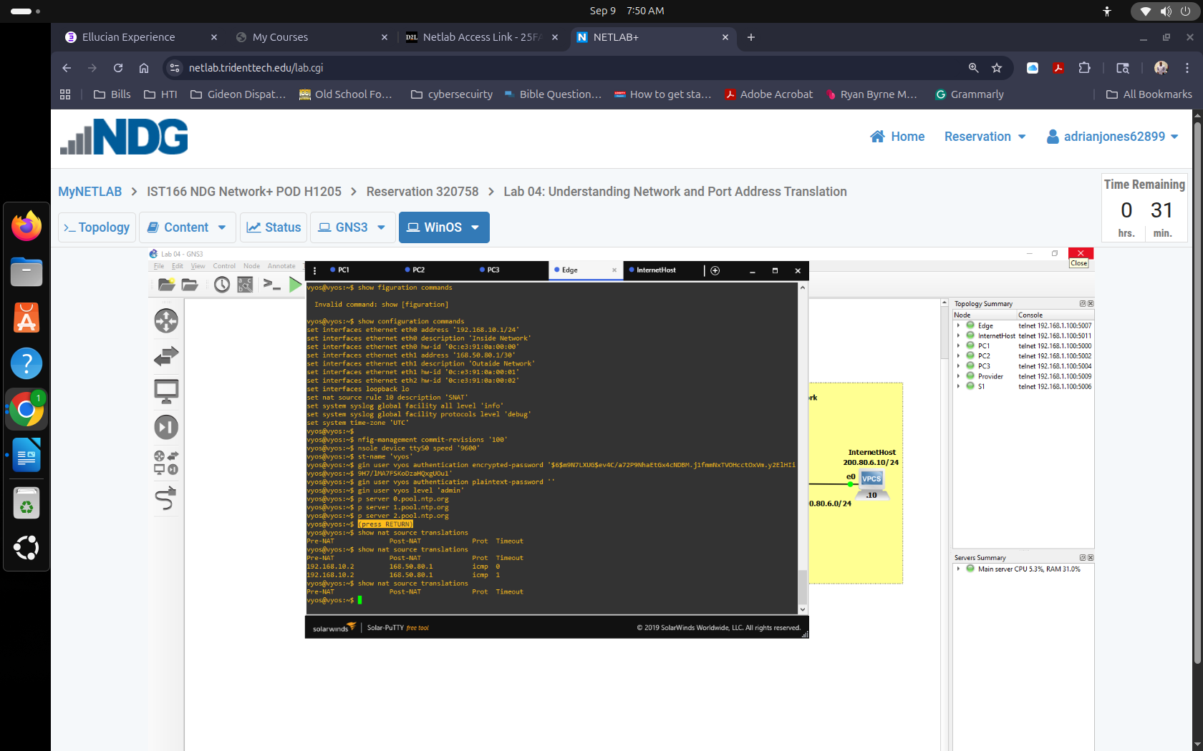
Step 7 Page 32 of 33
